Packet Tracer - Configure DHCPv4

Cisco Systems, Inc.

|  |  |
| --- | --- |
| **NAME** | **MOHAMAD SAIFUL NIZAM BIN ABD AZIZ** |
| **NO. MATRIC** | **A179830** |
| **INSTRUCTOR** | **TS. DR. WAN FARIZA BINTI FAUZI** |

Packet Tracer - Configure DHCPv4

# Addressing Table

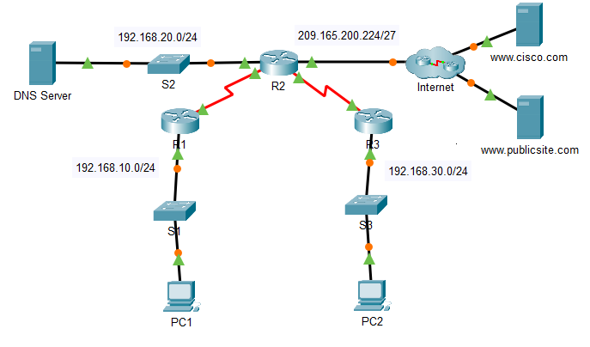

|  |  |  |  |  |
| --- | --- | --- | --- | --- |
| Device | Interface | IPv4 Address | Subnet Mask | Default Gateway |
| R1 | G0/0 | 192.168.10.1 | 255.255.255.0 | N/A |
| R1 | S0/0/0 | 10.1.1.1 | 255.255.255.252 | N/A |
| R2 | G0/0 | 192.168.20.1 | 255.255.255.0 | N/A |
| R2 | G0/1 | DHCP Assigned | DHCP Assigned | N/A |
| R2 | S0/0/0 | 10.1.1.2 | 255.255.255.252 | N/A |
| R2 | S0/0/1 | 10.2.2.2 | 255.255.255.252 | N/A |
| R3 | G0/0 | 192.168.30.1 | 255.255.255.0 | N/A |
| R3 | S0/0/1 | 10.2.2.1 | 255.255.255.0 | N/A |
| PC1 | NIC | DHCP Assigned | DHCP Assigned | DHCP Assigned |
| PC2 | NIC | DHCP Assigned | DHCP Assigned | DHCP Assigned |
| DNS Server | NIC | 192.168.20.254 | 255.255.255.0 | 192.168.20.1 |

Blank Line - no additional information

# Objectives

Part 1: Configure a Router as a DHCP Server

Part 2: Configure DHCP Relay

Part 3: Configure a Router as a DHCP Client

Part 4: Verify DHCP and Connectivity

# Scenario

A dedicated DHCP server is scalable and relatively easy to manage but it can be costly to have one at every location in a network. However, a Cisco router can be configured to provide DHCP services without the need for a dedicated server. As the network technician for your company, you have been assigned the task of configuring a Cisco router as a DHCP server. You are also required to configure the edge router as a DHCP client so that it receives an IP address from the ISP network.

# Instructions

## Configure a Router as a DHCP Server

### Configure the excluded IPv4 addresses.

Addresses that have been statically assigned to devices in the networks that will use DHCP must be excluded from the DHCP pools. This avoids errors associated with duplicate IP addresses. In this case the IP addresses of the R1 and R3 LAN interfaces must be excluded from DHCP. In addition, nine other addresses are excluded for static assignment to other devices such servers and device management interfaces.

* + - 1. Configure **R2** to exclude the first 10 addresses from the R1 LAN.

Open configuration window

R2(config)# **ip dhcp excluded-address 192.168.10.1 192.168.10.10**

* + - 1. Configure **R2** to exclude the first 10 addresses from R3 LAN.

### Create a DHCP pool on R2 for the R1 LAN.

* + - 1. Create a DHCP pool named **R1-LAN** (case-sensitive).

R2(config)# **ip dhcp pool R1-LAN**

* + - 1. Configure the DHCP pool to include the network address, the default gateway, and the IP address of the DNS server.

R2(dhcp-config)# **network 192.168.10.0 255.255.255.0**

R2(dhcp-config)# **default-router 192.168.10.1**

R2(dhcp-config)# **dns-server 192.168.20.254**

### Create a DHCP pool on R2 for the R3 LAN.

* + - 1. Create a DHCP pool named **R3-LAN** (case-sensitive).
      2. Configure the DHCP pool to include the network address, the default gateway, and the IP address of the DNS server. Refer to the Addressing Table.

Close configuration window

## Configure DHCP Relay

### Configure R1 and R3 as a DHCP relay agent.

For DHCP clients to obtain an address from a server on a different LAN segment, the interface that the clients are attached to must include a helper address pointing to the DHCP server. In this case, the hosts on the LANs that are attached to R1 and R3 will access the DHCP server that is configured on R2. The IP addresses of the R2 serial interfaces that are attached to R1 and R3 are used as the helper addresses. DHCP traffic from the hosts on the R1 and R3 LANs will be forwarded to these addresses and processed by the DHCP server that is configured on R2.

* + - 1. Configure the helper address for the LAN interface on R1.

Open configuration window

R1(config)# **interface g0/0**

R1(config-if)# **ip helper-address 10.1.1.2**

* + - 1. Configure the helper address for the LAN interface on R3.

### Configure hosts to receive IP addressing information from DHCP.

* + - 1. Configure hosts PC1 and PC2 to receive their IP addresses from a DHCP server.
      2. Verify that the hosts have received their addresses from the correct DHCP pools.

Close configuration window

## Configure a Router as a DHCP Client

Just as a PC is able to receive an IPv4 address from a server, a router interface has the ability to do the same. Router **R2** needs to be configured to receive addressing from the ISP.

* + - 1. Configure the Gigabit Ethernet 0/1 interface on **R2** to receive IP addressing from DHCP and activate the interface.

Open configuration window

R2(config)# **interface g0/1**

R2(config-if)# **ip address dhcp**

R2(config-if)# **no shutdown**

**Note**: Use Packet Tracer’s **Fast Forward Time** feature to speed up the process.

* + - 1. Use the **show ip interface brief** command to verify that R2 received an IP address from DHCP.

## Verify DHCP and Connectivity

### Verify DHCP bindings.

R2# **show ip dhcp binding**

IP address Client-ID/ Lease expiration Type

Hardware address

192.168.10.11 0002.4AA5.1470 -- Automatic

192.168.30.11 0004.9A97.2535 -- Automatic

Close configuration window

### Verify configurations.

Verify that **PC1** and **PC2** can now ping each other and all other devices.

